Lab 6.3 Using ConfigMap

- Create a configmap-definition.yml file as below:
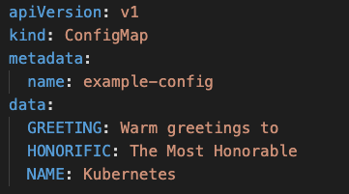

- Create the configmap
kubectl create -f configmap-definition.yml

- Check the configmap
kubectl get configmap
kubectl describe configmap

- Create a pod-definition.yml file as below
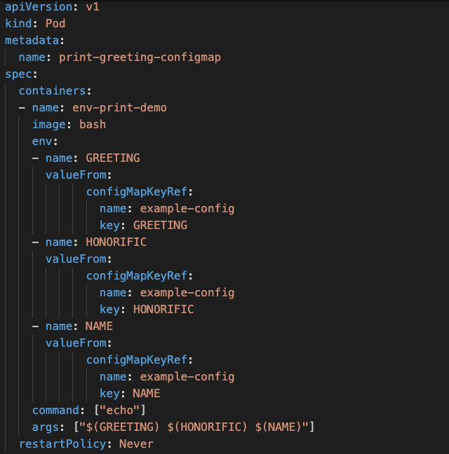

- Create the pod
kubectl create -f pod-definition.yml

- Check the Logs
kubectl logs -f print-greeting-configmap

